**On the work of a German team about modeling the evolution of Covid-19**

Because this work (with the code for the software treatment) “can be readily adapted to other countries or regions”, I try to give hints to understand and replicate the research done under the title:

[1] Inferring COVID-19 spreading rates and potential change points for case number forecasts <https://arxiv.org/pdf/2004.01105.pdf>

Jonas Dehning,1∗ Johannes Zierenberg,1∗ F. Paul Spitzner,1∗ Michael Wibral,2 Joao Pinheiro Neto,1 Michael Wilczek,1∗ Viola Priesemann1∗

1Max Planck Institute for Dynamics and Self-Organization, G ̈ottingen, Germany,

2Campus Institute for Dynamics of Biological Networks, University G ̈ottingen, Germany

∗Authors contributed equally. Correspondence to [viola.priesemann@ds.mpg.de](mailto:viola.priesemann@ds.mpg.de).

“Our framework can help to infer the effectiveness of past measures as well as to explore potential future scenarios with propagating the respective uncertainties. It can be readily adapted to other countries or regions. The code (already including data sources from many other countries), as well as the figures are all available on Github.” [<https://github.com/Priesemann-Group/covid19_inference_forecast>.]

1. Context :

1/ “During this initial,time-critical period, neither the central epidemiological **parameters**, nor the **effectiveness of measures** like cancellation of public events, school closings, and social distancing are known.”

2/ **Three steps of political interventions** to contain the outbreak in Germany:

S1/ “Around March 8, **cancelling of large public events** like soccer matches”

S2/ “On March 15, the **closing of schools and other educational institutions** along with the **closing of non-essential stores** were announced and imple-mented on the following day.”

S3/ “on March22, a far-reaching **contact ban**, which includes the prohibition of even small public gatherings as well as the further closing of restaurants and non-essential stores”

1. Objectives of the work :

T1: “we infer the **spreading rate** λ” ( central epidemiological **parameter**)

T2: “characterizes the **temporal change of the spreading rate**”

T3: “identify potential **change points** and provide **short-term forecast scenarios** based on various degrees of social distancing”

1. Methodology:

Inference “from confirmed COVID-19 case numbers at the example in Germany by combining **Bayesian inference** with a **SIR (Susceptible-Infected-Recovered) model** from compartmental epidemiology.”

“We use Bayesian Markov-Chain Monte Carlo sampling to estimate the **central epidemiological parameters** for our stationary SIR model, specified by a spreading rate λ, a recovery rate μ, a reporting delay D, and the number of initially infected people I0””

1. Results:

1/ with rapport to T1 and T2:

“**median estimates** for the spreading rate λ= 0.41, μ= 0.12, D= 8.7, and I0= 18.”

“a median R0 = λ/μ = 3.3 (CI [2.4, 4.7])”

“a **first change point** in the spreading rate from λ0= 0.41 (95 %Confidence interval (CI): [0.35, 0.49]) to λ1= 0.25 (CI:[0.20, 0.29]), which occurred around March 8 (CI: March5 to March 10).

(mifanaraka @ S1)

“a **second change point** to λ2= 0.13 (CI: [0.10, 0.17]), which occurred around March 16 (CI: March 15 to March 18). (mifanaraka @ S2)

Both changes in λ slowed the spread of the virus, but still imply exponential growth (Fig. 1, red and orange traces).

“**no sufficient observations** to infer the time and magnitude of the expected third change point, because of the **delay** between infection, case report, and inferred evidence of about two weeks (**caused** by the incubation period, reporting delay, accumulation of evidence; Fig. 1 B, C).

“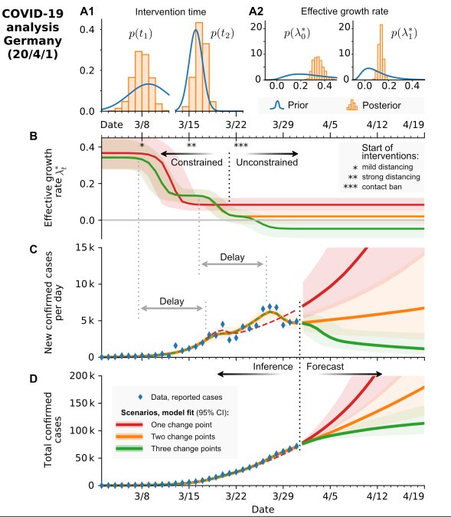

**Fig.1**

1. Further explanations about Fig. 1.

Fig A1 sy Fig A2:

Estimation of the **intervention time** (one of the central parameters of the SIR model): t1, t2

Estimation of the **change points** (at time t1 and t2).

Fig B:

Inferred **effective growth rate** λ∗=λ−μ, μ is the recovery rate.

Three models compared “by formal Bayesian comparison” :

Red trace: SIR model with one change point

Orange trace: SIR model with 2 change points

Green trace: SIR model with 3 change point

“The inferred change points correspond well to the timing of the governmental interventions in Germany”

Fig C,D:

**Model fit** of the new confirmed cases and (cumulative) total confirmed cases using the 3 models

Fig B,C: on delay

Note the delay D between change point (i.e. change in spreading behavior) and observation of confirmed cases of almost two weeks.

Fig A,B:

“good agreement for both new infections Ct (Fig. 1 A) and the cumulative infections ∑tt′=0Ct′ (Fig. 1 B) with the expected exponential growth (linear in lin-log plot).”

1. Numerical treatment of the SIR models

“We consider a time-discrete version of the standard SIR model. In short, we assume that the disease spreads at rateλfrom the infected population stock (I) to the susceptible population stock (S), and that the infected stock recovers (R) at rate μ.” [SIR without vital dynamic]

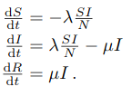

“Because our data set is discrete in time (∆t=1 day), we solve the above differential equations with a discrete time step”

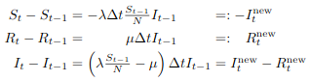

Fitting

1. Statistical treatment of the models

“We use Bayesian MCMC sampling to estimate the central epidemiological parameters for our stationary SIR model”

“We estimate the set of model parameters θ={λi, ti, μ, D, σ,I0} using Bayesian inference with Markov-chainMonte-Carlo (MCMC). The parameter σ is the scale factor for the width of the likelihood P(Ĉt|θ) between observed data and model. Our implementation relies on the python package pymc3 with NUTS (No-U-TurnSampling).”

“a Bayesian approach (to incorporate prior knowledge) with Markov Chain Monte Carlo (MCMC) sampling (to explore the parameters). Put simply, we first estimate the parameter distribution that best describes the observed situation, and then we use many samples from this parameter distribution to evolve the model equations and thus forecast future developments.”

“As long as the COVID-19 spread is still in the initial exponential growth phase, the SIR model can be approximated by an exponential function with effective growth rate λ∗=λ−μ (see Methods). As a consequence, λ and μ cannot be estimated independently by the MCMC sampling. This is further supported by a systematic scan of the **model’s log-likelihood** in the λ–μ space showing an equipotential line for the **maximum likelihood** (Fig. 1 J). This verifies that the effective growth rate λ∗ is the relevant free parameter with median λ∗= 28% from the **complete** **MCMC sampling** (Fig. 1 I).”

Fig C below: “Absolute difference between model and data (blue line) is captured by the demographic-noise width scale-factor σ we chose for the likelihood (Students t-distribution). The error of the likelihood function scales with the number of new cases as σ√Ct.”

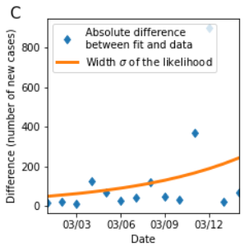

Fig J below: Log-likelihood distribution for different combinations of λ and μ. A linear combination of λ and μ yield the same maximal likelihood (black line).

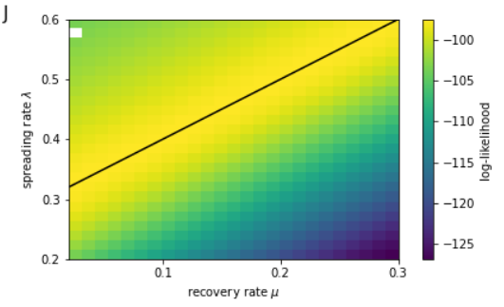

Inferrence:

“After parameter distributions were inferred on the real-world data up until 2020/03/15, hypothetical interventions were implemented by starting a transition from the past (inferred) spreading rateλ0to a new valueλ1on 2020/03/15.”

Inferred lambda_t

“The inferred temporal decrease of newcases, before increasing again, comes from changing an exponential growth rate over small time-interval in the model.” (Inferred new cases)

Many fits and forecasts

“identify potential **change points** and provide **short-term forecast scenarios** based on various degrees of social distancing”

“ Put simply, we first estimate the parameter distribution that best describes the observed situation, and then we use many samples from this parameter distribution to evolve the model equations and thus forecast future developments.”

Formal, leave-one-out (LOO) cross-validation based Bayesian model comparison [28] indicated that the models withtwo and three change points describe the data better than the models with zero or one change point (Table I)

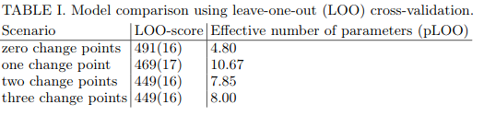

Model comparison

“Since change point detection entails evaluating models with different numbers of parameters, some form of fairmodel comparison needs to be performed. Here, we compared the models with different numbers of change points by their pointwise out-of-sample prediction accuracy using the log-likelihood evaluated at the posterior simulations of the parameter values obtained from the fitted models. Out-of-sample accuracy was approximated using Leave-one-out cross validation (LOO) [28].”

[28] A. Vehtari, A. Gelman, J. Gabry, *Stat Comput* 27, 1413 (2017).[29] S. A. Lauer,et al., Ann Intern Med (2020).

1. Software, code and all that

“Our implementation relies on the python package pymc3 [33] with NUTS (No-U-TurnSampling) [34].”

[33] J. Salvatier, T. V. Wiecki, C. Fonnesbeck, PeerJ Comput. Sci.2, e55 (2016).

[34] M. D. Hoffman, A. Gelman,J. Mach. Learn. Res.15, 1593 (2014).

“The code (already including data sources from many other countries), as well as the figures are all available on Github [23]”

[23]<https://github.com/Priesemann-Group/covid19_inference_forecast>.

“The code used to produce the figures is available [here](https://github.com/Priesemann-Group/covid19_inference_forecast/blob/master/scripts/paper/Corona_germany_simple_model.ipynb) (simple model) and [here](https://github.com/Priesemann-Group/covid19_inference_forecast/blob/master/scripts/paper/SIR_with_delay_Germany_3scenarios.ipynb) (with change points). It is runnable in Google Colab. Requirement is PyMC3 >= 3.7.”

“If you want to use the code, we recommend you to look at our [documentation](https://covid19-inference-forecast.readthedocs.io/en/latest/).”

**Fanamarihana**:

Misy fikarohana hafa mampiasa modely tahaka ny modely SIR:

[1] ASSESSING THE EFFICIENCY OF DIFFERENTCONTROL STRATEGIES FOR THE CORONAVIRUS(COVID-19) EPIDEMIC <https://arxiv.org/pdf/2004.03539.pdf>

C ́ESAR CASTILHO1, JO ̃AO A. M. GONDIM2, MARCELO MARCHESIN3,MEHRAN SABETI4

1Departamento de Matem ́atica Universidade Federal de Pernambuco Recife, PE CEP 50740-540 Brazil

2Unidade Acadˆemica do Cabo de Santo AgostinhoUniversidade Federal Rural de PernambucoCabo de Santo Agostinho, PE CEP 54518-430 Brazil

3Departamento de Matem ́aticaUniversidade Federal de Minas GeraisBelo Horizonte, MG CEP 31270-000 Brazil

4Instituto de Ciˆencias Exatas e Tecnol ́ogicasUniversidade Federal de Vi ̧cosa Campus-FlorestalVi ̧cosa, MG CEP 35690-000 Brazil.

[2] A simulation of a COVID-19 epidemic based ona deterministic SEIR model

<https://arxiv.org/pdf/2004.03575.pdf>

Jos ́e M. Carcione1·Juan Santos2Claudio Bagaini3·Jing Ba4

1National Institute of Oceanography and Applied Geophysics – OGS, Trieste, Italy. E-mail: jcarcione@inogs.it2Buenos Aires University, Argentina and Purdue University, USA.3Haywards Heath, UK.4Hohai University, Nanjing, China.